Chapter 1

Collision Theory

Rate of reaction is determined by the number of successful collisions in a given time.

Greater number of successful collisions = to faster rate of reaction.

States that for a reaction to occur:

* Reacting particles must collide
* Collision energy must equal or exceed activation energy (Ea)
* Must collide with suitable orientation (Transition State)

Factors affecting reaction rate

* Concentration/partial pressure: if concentration of a reactant is increased, then there will be more particles in a given volume. Makes it more likely for reactant particles to collide, therefore more collisions. *Only for reactants in solution or gaseous phase.
* Pressure: pressure of a gas is due to force exerted by particles colliding with the walls of the container. An increase in pressure means more particles in a given volume. Thus, concentration of gas particles will increase and therefore more collisions between particles. Reverse happens at decrease of pressure.
* Temperature: Increased temperature means increased average kinetic energy. This means more particles will have sufficient energy for a successful collision. Increased kinetic energy associated with increased speed of particles, thus more frequent collisions.
* Surface Area: In solids, only exterior of particles can collide. If surface area is increased by division or crushing, more particles will be exposed and be available for collision.
* Catalysts: Provide an alternative, easier pathway for reaction. This means lower activation energy, so more particles will have sufficient energy for a successful collision.
* Nature of Reactants: Ionic reactions are rapid as they do not involve the breaking of bonds or electron transfer between reacting particles. Molecular reactions are slow since they involve breaking and bond formation. Collisions are often unsuccessful at room temperature due to insufficient activation energy.

Energy Changes

Exothermic:

* Loses heat to surroundings.
* There is a negative change in enthalpy.
* Some of the chemical potential energy stored in bonds is converted to particle kinetic energy. Causes increase in system’s temperature.
* Overall energy is conserved with chemical potential energy becoming ‘heat’ energy.

Endothermic:

* Gains heat from surroundings.
* There is a positive change in enthalpy.
* Fall in temperature due to particle kinetic energy converted to chemical potential energy.
* Initially there is no change in enthalpy.

Chapter 2

# Reversible Reactions

* Have a low activation energy for forward and reverse reaction
* Don’t go to completion as once the products form they react to reform reactants
* In closed systems, forward & reverse reactions compete with 1 another preventing the reaction from completing in either direction

## Equilibriums

Properties:

* Reversible
* Dynamic
* Macroscopic properties are constant (colour, pressure, temperature)

## Physical Equilibrium

Example: Water

H2O(l) ⇄ H2O(g)

* In a closed system, the vapor is unable to escape so it reverts back to a liquid. Therefore a reversible reaction.
* Initially, the forward reaction dominates the reverse.
* However, as vapor concentration increases; the rate of vapour condensation also increases until they are equal. The rate of condensation = rate of evaporation.

*See Fig 1.*

## Chemical Equilibrium

Example:

2NO2(g) ⇄ N2O4(g)   Change in Enthalpy: -57kJ

(brown)   (colourless)

* In a closed system, NO2 ‘s molecules will combine to form N2O4 molecules.
* Overtime this reduces NO2’s concentration, hence reducing rate of reaction.
* As N2O4 begins to form, it can decompose intoNO2.
* This results to both their concentrations are such that the reaction reaches equilibrium.

## Equilibrium Position

* Relative concentration of reactants to products is different for different systems.
* Equilibrium constant, Kc gives a numerical value relating concentration of all species in a system at Equilibrium.

Equilibrium constant expression:

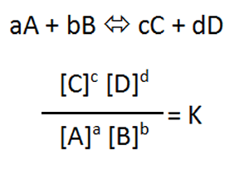

* Square brackets as an abbreviation for concentration.

* Only aqueous and gases appear in expression. Solids and liquids have a fixed concentration
* Kc has no units
* Kc has a constant value for all conditions of concentration and pressure
* Kc changes with temperature
* Kc is always positive
* Kc>1 : reaction favours products
* Kc >>1 (eg 103) : reaction very strongly favours products
* Kc<1 : reaction favours reactants
* Kc<<1 (eg 10-3) : reaction very strongly favours reactants
* Values close to 1 imply equal of both reactants and products

*Water is always neutral

Reaction quotient expression:

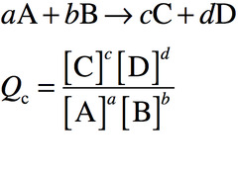

* For a system not necessarily at equilibrium
* If Qc=Kc then system is at equilibrium

## Shifting the equilibrium position

A chemical equilibrium system can return to a state of equilibrium after alterations (imposed changes)

Imposed changes:

* Concentrations of any 1 species (removing or adding)
* Total pressure in gaseous system (raising/lowering volume)
* Temperature of system (add/remove heat from system)

## Le Chatelier’s Principle

“If a change in conditions is made to a chemical system in equilibrium, then the system will adjust in such a way as to partially counteract the imposed change.”

### **Effect of changing concentration**

Example: In a system at equilibrium, more of a particular substance is added. This increases concentration of substance and rate of reaction.

PCl3(g) + Cl2(g) ⇄ PCl5(g)

* More Cl2 is added.
* Forward reaction rate increases
* Reverse initially not affected
* As more PCl5 is produced however, the reverse reaction rate increases
* A new equilibrium is eventually reached with identical new forward and reverse reaction rates

Explanation:

* If the concentration of reaction is increased, then the forward reaction also increases
* Overtime the concentration of reactants reduces as they are temporarily used faster than produced
* There is also an increase in concentration of product as it is temporarily produced faster than used.
* Forward reaction rate slowly decreases as fall in reactant concentration and collision rates.
* Reverse reaction rate slowly increases.
* Concentration changes continue until rate of forward = rate of reverse.
* Therefore there is a partial reduction and a new equilibrium is formed.

*In aqueous solutions, adding water decreases concentration of all aqueous substances. The reaction creating the most aqueous molecules is then favoured.

*See Fig 2. & 3.*

### **Changing the total pressure**

If a container volume is altered, then the total pressure is changed.

* Increase in volume = decrease in total pressure.
* Decrease in volume = increase in total pressure.
* Less molecules = less pressure

Le Chatelier’s principle states that the equilibrium will re-establish itself to minimise pressure change by altering total moles of gas present.

* Increasing pressure favours equilibrium reaction side with fewer moles of gas.
* Fewer moles of gas means less pressure within system, thus partially counteracting imposed change
* Eg: if less moles in reactants then that is favoured.
* Decreasing pressure favours equilibrium reaction side with the greater moles of gas.
* More moles of gas means more pressure, thus partially counteracting imposed change.

*If both sides have same number of moles of gas then changing the pressure has no effect on equilibrium position.

*Adding an inert gas has no effect.

*Changing pressure by selectively adding or removing 1 of the gaseous reactants or products is equivalent to altering the concentration only.

*See Fig 4.*

### **Temperature change**

If temperature of system at equilibrium is altered, the system changes to minimise temperature change.

* Increase in temperature: favour in endothermic process. System converts added heat to chemical potential energy. This causes temperature to fall.
* Decrease in temperature: favour in exothermic process. Converts chemical potential energy to heat. Causes temperature to rise.

Explanation:

Collision theory states a temperature rise will increase average  particle collision energy and reaction rate.

However endothermic reaction rates are much more sensitive to temperature change than exothermic.

So raising temperature in equilibrium, the rate of endothermic reaction increases more than exothermic reaction.

Therefore…

Increasing temperature lowers endothermic reaction rate more than exothermic

* This is why increasing temperature favours endothermic and decreasing temperature favours exothermic.

Also: changing temperature causes a change in the value of Kc.

* In endothermic, Kc increases as temperature increases.
* In exothermic, Kc decreases as temperature increases.

### **Other Alterations**

* Catalysts have no effect on equilibrium position
* Catalysts will speed up rate of attainment of equilibrium. → due to catalyst increasing both forward and reverse equally.

Removal of reactants and products present as a solid or liquid doesn’t alter equilibrium concentration or amount of any other species (Due to their fixed concentration)

Chapter 3

Physical Properties

|  |  |
| --- | --- |
| Acids | Bases |
| Conduct electric current | Conduct electric current |
| Turn blue litmus red | Turn red litmus blue |
| Sour taste | Bitter taste |
|  | Slippery soapy feel |

Chemical properties:

Acid + Metal → Salt + H2(g)

Acid + Metal Hydroxide → Salt + H2O

Acid + Metal Oxide → Salt + H2O

Acid + Carbonate → Salt + H2O + CO2(g)

Acid + Hydrogen Carbonate → Salt + H2O + CO2(g)

Acid + Metal Sulfite → Salt + H2O + SO2(g)

Base + Ammonium Salt → Salt + H2O + NH3(g)

Base + Non-metal Oxide → Salt + H2O

Chapter 4

|  |  |
| --- | --- |
| Strong Acids | Strong Bases |
| Hydrochloric acid, HCl  Nitric Acid, HNO3  Sulfuric Acid, H2SO4 | Sodium Hydroxide, NaOH  Potassium Hydroxide, KOH  Barium Hydroxide, Ba(OH)2  Sodium Oxide, Na2O |
| Weak Acids | Weak Bases |
| Ethanoic acid, CH3COOH  Carbonic acid, H2CO3  Hydrofluoric acid, HF  Citric acid, C6H8O7 | Ammonia, NH3  Methylamine, CN3NH2 |

Concentration

Strong acid completely ionised in aqueous solution thus producing a higher H+ concentration than a weak acid which only partially ionises in aqueous solution. Thus strong acid produces highest H+ concentration for same acid concentration.

Arrhenius Theory

Acids:

An acid will ionise and produces H+ ions when dissolved in water.

HCl(g) → H+(aq)+ Cl-(aq)  
Bases:

A base will dissociate and  produces OH-  ions  when dissolved in water.

NaOH(s) → Na+(aq) + OH-(aq)

* Theory is limited as it only applies to acid-base behaviour in aqueous solutions.
* Does not explain or predict basic nature of other compounds such as carbonates and oxides or salts.
* None of which contain OH-.

Bronsted-Lowry Theory

Explains acid base behaviour in terms of proton transfer between 2 species. Classifies  substances as acids or bases in the context of a given reaction.

* An acid acts as a proton (H+) donor

HCl(g)+H2O(l) ⇌ H3O+(aq) + Cl-(aq)

Acid          Base     Hydronium Ion

Conjugate Acid Conjugate Base

* A base acts as a proton (H+) acceptor

NH3 + H2O(l) ⇌ NH4+(aq) + OH-(aq)

Base         Acid      Conjugate acid Conjugate base

Bronsted-Lowry proton transfer reaction requires both an acid and base to be present for a reaction to occur. In this case, water is behaving as an acid.

Conjugate Acids and Bases

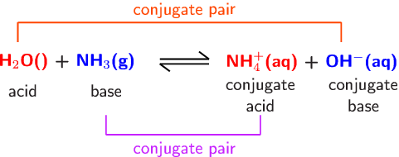

* When an acid donates a proton, what is left behind is its conjugate base.
* When a base accepts a proton, the substance formed is its conjugate acid.

Acidity Constant Ka and Acid Strength

A numerical measure of the extent to which the proton transfer reaction goes to completion, an indicator of acid strength.

HA(aq) + H2O(l) ⇌ H3O+(aq) + A-(aq)

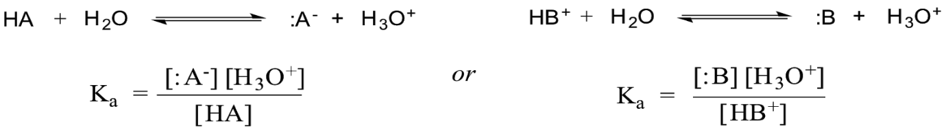

* H2O has a fixed concentration, so it is not included.
* Proton transfer equation is for the transfer of a single proton.
* Large Ka, greater tendency for acid to donate proton to water. Therefore stronger acid and greater degree of its ionisation.
* Small Ka means weak acid.
* While it indicates strength of acid, it also indicates strength of conjugate base to accept proton back from water.
* If Ka is very large then the conjugate base is extremely weak (possible neutral).
* As Ka is progressively smaller and the acid progressively weaker, the conjugate base becomes progressively stronger.

Polyprotic Acids

Acids like HCl are said to be monoprotic, can only donate 1 proton per acid molecule.

Polyprotic acids are able to donate more than 1 proton per molecule of acid:  
Diprotic has 2 acidic hydrogen atoms, eg: H2SO4.

Triprotic has 3 acidic hydrogen atoms, eg: H3PO4.

* The conjugate base of a polyprotic acid is usually acidic in relation to water. However its acid strength is always less than the original acid.

H2SO4(aq) + H2O(l) ⇌ H3O+(aq) + HSO4-(aq) -first proton transfer, Ka approx. 109

HSO4-(aq) + H2O(l) ⇌ H3O+(aq) + SO42-(aq) -2nd proton transfer, Ka = 1.0x10-2

* Subsequent acidity constants decrease with each proton transfer. Due to each subsequent conjugate base of original acid having an increasingly negative charge making it harder to donate a hydrogen ion (positive).

Acid-base Properties of Salts

In an acid-base reaction, the salt formed is not always neutral.

Acidic or basic salts arise from the hydrolysis (reaction with water) reactions of cations/anions derived from the weak acid or base.

If one of the ions present in a salt reacts with water acting as a proton donor (acid), then solutions will be acidic.

Eg: Ammonium, a weak acid.

NH4+ + H2O ⇌ H3O+ + NH3

Formation of H3O+ gives an acidic solution.

|  |  |  |
| --- | --- | --- |
|  | Strong Base | Weak Base |
| Strong Acid | Neutral salt | Acidic Salt |
| Weak Acid | Basic salt | Neutral salt |

Cations (+)

|  |  |  |
| --- | --- | --- |
| Acidic | Neutral | Basic |
| NH4+ | The Rest | None |
| Fe3+ |  |  |
| Al3+ |  |  |

Anions (-)

|  |  |  |
| --- | --- | --- |
| Acidic | Neutral | Basic |
| H2PO4- | Cl- | The rest |
| HSO4- | Br- |  |
|  | I- |  |
|  | NO3- |  |

Kw and the autoionisation of water

Some H2O (extremely small) change into H+ and OH-  ions.

* The ions are produced in equal numbers by a reversible reaction known as autoionisation or self-ionisation.

H2O(l) ⇌ H+(aq) + OH-(aq)OR         2H2O(l) ⇌ H3O+(aq) + OH-(aq)

* Both ions have the same extremely low concentration: 1.0x10-7 mol L-1 at 25C.
* therefore conc of ions is so low that the conductivity of pure water is negligible.
* In water or any solution with the same concentration as H and OH, it is neutral.
* If extra H or OH is added the equilibrium will re-establish a new equilibrium. Adding acid to water raises H concentration and lowers OH concentration.

Equilibrium expression for self-ionisation of water; kw:

H2O(l) ⇌ H+(aq) + OH-(aq)Change in Enthalpy = 55.8kJ

Kw = [H+][OH-] = 1x10-14 also Kw=c(H+) x c(OH-)= 1x10-14

Note:

* Shows H and OH are inversely related, an increase in H causes a decrease in OH vice versa.
* The small value indicates the strong tendency for water to remain in the unionised, molecular form of H2O molecules.
* Kw changes value with temperature. As autoionisation of water is endothermic, higher temperatures will favour the formation of products. This means that concentration of H and OH both rise with increasing temperature.
* Kw  will be higher at higher temperatures.

Acidity and pH

Acidity depends upon its H concentration.

* H concentration in most solutions can range from approx. 10 mol L-1 (very acidic) to 1x10-15 mol L-1 (very basic).
* pH = -log[H+]    ← concentration of H

For solutions of a strong acid or strong base with a known concentration, pH and Kw relationship can be used to calculate its pH.

If the pH of a solution is known then both H and OH concentrations can be found.

Buffers

Buffers are solutions that have the ability to resist pH change when acids or bases are added to them.

* Generally a buffer solution is one that contains a weak acid-base conjugate pair.

(Weak acid + conjugate weak base or weak base + conjugate weak acid)

* This can exist as the weak acid and base can co-exist without neutralising and can still react to neutralise any strong acid or base added.

*Example: Ethanoic acid/Sodium Ethanoate*

CH3COOH(aq) + H2O(l)⇌ CH3COO(aq)- + H3O+(aq)

*Adding an acid:* increase in concentration of H3O+ initially. Equilibrium shifts to the left to oppose change. Thus, most of added H3O+ is consumed. Therefore, prevents H3O+(aq) from rising significantly. Resisting any change in pH.

*Adding a base:* increased OH- ion concentration in system. This neutralises some of the H3O+ present in the solution causing its concentration to initially fall. The falling concentration causes the equilibrium to shift to the right to oppose this change, thus replacing most of the lost H3O+ preventing concentration from falling significantly. Resisting any change in pH.

Buffer Capacity

The ability of the buffer to resist changes in pH. It refers to the amount of H+ or OH- that can be added without causing a 1 unit change to the pH of the buffer solution.

* Buffering capacity increases as the concentration of the acid/conjugate base pair is increased.
* The greater the concentration of acid/conjugate base pair, the greater the amount of H+ or OH- that can be added without overwhelming the buffer’s capacity to maintain a constant pH.
* For a solution to be most effective, a high concentration of weak acid and base is required.
* Ensures neither weak acid or conjugate base are significantly depleted or reduced in concentration with addition of OH or H.
* Also most effective with similar concentrations.

Blood Chemistry

The main buffer system in blood is the carbonic acid/hydrogen carbonate ion system.

Human blood is 7.35-7.45.

H2CO3(aq) + H2O(l) ⇌ HCO3-(aq) + H3O+(aq)

* If blood becomes too acidic, reverse reaction occurs to reduce excess H3O+
* If blood becomes too basic, forward reaction occurs to increase H3O+ and neutralise excess base.

Chapter 5

## Acid-base Titrations

Involve reactions between solutions of acids and bases.

* The concentration of one solution must be accurately known (standard solution).
* The other solution’s concentration isn’t known

Titration is used to determine concentration of acid or base in solution of unknown concentration.

* Equivalence point happens when sufficient acid or base has been added to just neutralise each other, neither acid nor base remain in the flask.
* End point is where indicator changes colour signalling the equivalence has occurred. The end point is a very close approximation of the equivalence point.

Process:

One solution is added from a burette (titre) to a carefully measured volume of the other solution (aliquot) which is placed into a conical flask.

## Primary Standards and Primary Standard Solutions

Primary standard solution: accurately known concentration used in a titration to find concentration of other reagents.

* Achieved by carefully weighing a sample of primary standard, dissolving this in distilled water and then making the solution up to a precise volume in a volumetric flask.

**Primary Standards:**  
- Obtainable in a very pure form

- Doesn’t react with anything from the air, such as H2O & CO2

- Have a relatively high molar mass

- soluble in water

2 Primary standards are:

Anhydrous sodium carbonate (Na2CO3)

Oxalic acid (H2C2O4 . 2H2O)

**Secondary Standard Solution:**

Solution which concentration is found through titration.

Eg: HCl or NaOH

Can then be used as the solution of known concentration in other titrations.

* May have error due to extra measurements & procedures.

### **Acid-base Indicators**

Indicators are weak acids or bases whose acid & bases form different colours.

Only small drops of indicator solution should be used. A large amount could alter volume required for equivalence.

### **Titration Curves:**

Strong acid with strong base

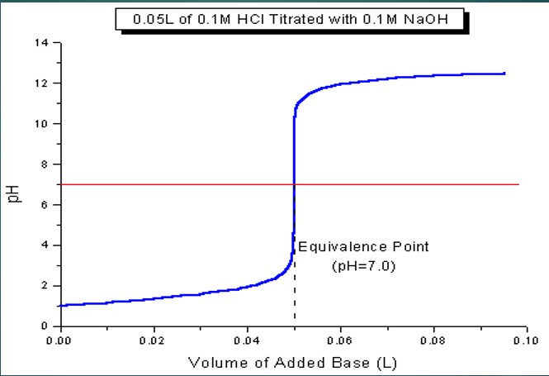

Strong acid with weak base

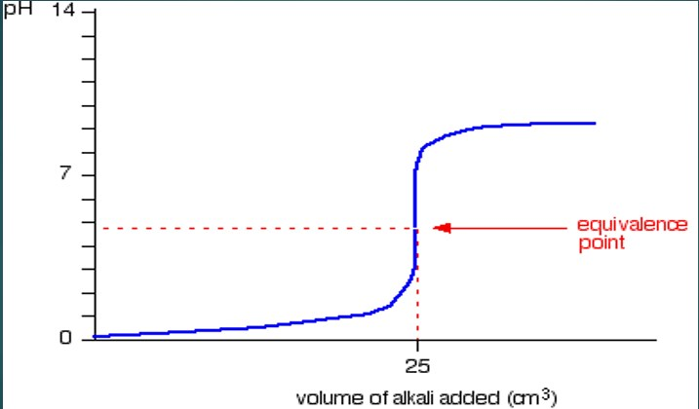

Weak acid with strong base

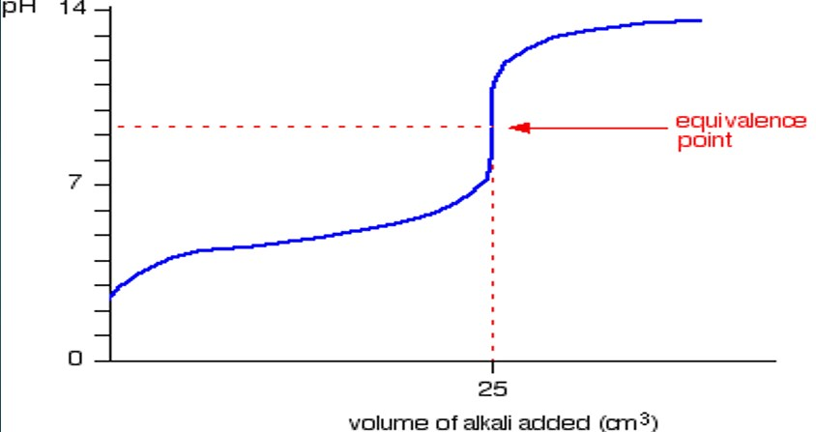

Chapter 6

Redox Reactions

Involve the transfer of electrons from 1 species to another.

Oxidation-

* The loss of electrons
* Gain of oxygen
* Loss of hydrogen
* Increase in Oxidation number

Reduction-

* The gain of electrons
* Loss of oxygen
* Gain of hydrogen
* Decrease in oxidation number

Oxidising agent or oxidant: species that is reduced, causes substance to be oxidised

Reducing agent or reductant: species that is oxidised, causes a substance to be reduced

Oxidation Numbers

|  |  |
| --- | --- |
| Species | Oxidation Number |
| Atoms in the elemental state | 0 |
| Monatomic ions  (Groups I metals in combined state)  (Groups II metals in combined state) | Charge on the ion  +1  +2 |
| Oxygen in combined state  Exception 1: peroxides eg: Na2O2, H2O2  Exception 2: F2O | -2  -1  +2 |
| Hydrogen in combined state  Exception: metal hydrides eg: NaH | +1  -1 |
| For polyatomic species the sum of the oxidation numbers | Charge on the ion |

Half-equations

* Oxidation half-equation shows species which is oxidised. Electrons are on the product side of the half-equation.
* Reduction half-equation shows species which is reduced. Electrons on reactant side of half-equation

Balancing Half-equations

1. Use oxidation numbers to identify the element being oxidised or reduced
2. Write skeleton equation (reactant → product)
3. Balance number of atoms of element being oxidised or reduced
4. Balance oxygen atom by adding H2O
5. Balance hydrogen atoms by adding H+
6. Balance charge by adding electrons to the side that is most positive

Balancing using half-equations

* Half equations can be added so that the number of electrons for each half equations is equal.
* When the 2 half-equations are added together electrons don’t appear in overall redox equation.